
SRM Institute of Science and Technology
Register Number
College of Engineering and Technology
School of Computing
SRM Nagar, Kattankulathur – 603203, Chengalpattu District, Tamilnadu
Academic Year: 2024 - 25 EVEN
B. Tech-School of Computing
Test: FT3 Date: 08.04.2025
Course Code & Title: 21CSE356T – Natural Language Processing Duration: 2 periods
Sem: VI Sem Max. Marks: 50
Batch I SET: D
Course Articulation Matrix:
S.No. | Course Outcome | PO1 | PO2 | PO3 | PO4 | PO5 | PO6 | PO7 | PO8 | PO9 | PO10 | PO11 | PO12 | PSO1 | PSO2 | PSO3
1 | CO1 | 3 | 3 | 2 |  |  |  |  |  |  |  |  |  | 2
2 | CO2 | 3 | 3 | 2 |  |  |  |  |  |  |  |  |  | 2
3 | CO3 | 3 | 3 | 2 |  |  |  |  |  |  |  |  |  | 2
4 | CO4 | 3 |  |  | 3 | 3 |  |  |  |  |  |  |  | 2
5 | CO5 |  |  | 2 | 3 | 3

Part – A
Answer all questions (10 x 1=10 marks)
Q. No | Question | Answers | Marks | BL | CO | PO | PI Code
 | N-grams are defined as the combination of N keywords together. How many bi grams can be generated from given sentence: “NPTEL videos are a great source to learn engineering courses”  6 B. 9 C. 7 D. 8 |  | 1 | 2 | CO3 | 3 | 3.1.1
 | Characterizing the meaning of words in terms of its relationship to other words such as synonymy, antonymy, and hyponymy is called ---------------  A. Semantic analysis B. Lexical relationship  C. Collocation D. Gradable antonyms |  | 1 | 2 | CO3 | 3 | 3.1.1
 | Identify the NLP technique used in this Input text “The cat sat on mat. The mat was red. The cat was black”.  - Text Coherence  - Anaphora Resolution  - Pronoun  - Text Non-Coherence |  | 1 | 2 | CO3 | 3 | 3.1.1
 | When analyzing a conversation, which component of discourse structure helps in identifying the relationship between individual utterances and their sequential organization?  A. Text coherence  B. Discourse planning  C. Discourse markers  D. Discourse structure |  | 1 | 2 | CO3 | 3 | 3.1.1
 | Difficulties/Challenges in Word Sense Disambiguation (WSD). Tick which is FALSE from the statements given below.  A. Completely different algorithm might be needed for different applications  B. to decide the sense of the word because different senses can be very closely related  C. The problem of Inter-judge variance as the WSD systems are generally tested by having their results on a task compared against the task of human beings  D. Words can be easily divided into discrete sub-meanings |  | 1 | 2 | CO3 | 3 | 3.1.2
 | Identify the difference between recurrent neural network (RNN) from a feedforward neural network?  A. RNNs can handle variable-length sequences of data  B. Feedforward networks use feedback loops for information flow  C. RNNs are deeper and have more hidden layers  D. Feedforward networks are better suited for time-series data |  | 1 | 2 | CO4 | 4 | 4.1.1
 | Select the suitable machine learning technique that allows a neural network to focus on specific parts of an input sequence?  A. Long Short-Term Memory (LSTM)  B. Encoder-decoder  C. Attention mechanism  D. Convolutional neural network (CNN) |  | 1 | 2 | CO4 | 4 | 4.1.3
 | Find the suitable statement about the encoder and decoder components of a transformer model?  A. The encoder ingests an input sequence and produces a single hidden state. The decoder takes in the hidden state from the encoder and produces an output sequence.  B. The encoder ingests an input sequence and produces a sequence of hidden states. The decoder takes in the hidden states from the encoder and produces an output sequence.  C. The encoder ingests an input sequence and produces a sequence of tokens. The decoder takes in the tokens from the encoder and produces an output sequence.  D. The encoder ingests an input sequence and produces a sequence of images. The decoder takes in the images from the encoder and produces an output sequence. |  | 1 | 2 | CO4 | 4 | 4.1.1
 | What is a term frequency-inverse document frequency (TF-IDF) in text classification?  - A document's class label  - A type of punctuation mark  - A technique for weighting the importance of terms in a document  - A measure of sentiment polarity |  | 1 | 2 | CO4 | 4 | 4.2.1
 | The first sentence is “Bob is a nice person,” and the second sentence is “Dan, on the Other hand, is evil”. Which gate is used to replace the first sentence name Bob with Dan.  - Input Gate  - Output Gate  - Forget Gate  - Remember Gate |  | 1 | 2 | CO4 | 4 | 4.1.1

SRM Institute of Technology
Register Number
College of Engineering and Technology
School of Computing
SRM Nagar, Kattankulathur – 603203, Chengalpattu District, Tamil Nadu
Academic Year: 2024 - 25 EVEN
B. Tech-School of Computing
Test: FT3 Date: 08.04.2025
Course Code & Title: 21CSE356T – Natural Language Processing Duration: 2 periods
Sem: VI Sem Max. Marks: 50
Batch I SET: D
Course Articulation Matrix:
S.No. | Course Outcome | PO1 | PO2 | PO3 | PO4 | PO5 | PO6 | PO7 | PO8 | PO9 | PO10 | PO11 | PO12 | PSO1 | PSO2 | PSO3
1 | CO1 | 3 | 3 | 2 |  |  |  |  |  |  |  |  |  | 2
2 | CO2 | 3 | 3 | 2 |  |  |  |  |  |  |  |  |  | 2
3 | CO3 | 3 | 3 | 2 |  |  |  |  |  |  |  |  |  | 2
4 | CO4 | 3 |  |  | 3 | 3 |  |  |  |  |  |  |  | 2
5 | CO5 |  |  | 2 | 3 | 3

Part –B
Answer ALL questions (4 x 5=20 marks)
Q. No | Question | Marks | BL | CO | PO | PI Code
11.a. | Define Coreference Resolution. Differentiate Pronominal Anaphora Resolution and Cataphora.  Solution:  Definition: coreference resolution is the task of determining whether two mentions corefer, by which we mean they refer to the same entity in the discourse model (the same discourse entity). The set of coreferring expressions is often called a coreference chain or a cluster.  AnaPhora:  Anaphora is the linguistic phenomenon of pointing back to a previously mentioned item in the text. Varieties of anaphora include pronominal anaphora, lexical noun phrase anaphora, and nominal anaphora. The interpretation of anaphora is crucial for the successful operation of a machine translation system.  CataPhora:  The term Cataphora refers to a linguistic and computational concept that involves pronouns or phrases that refer back to a previous word or phrase, often used to create cohesion and maintain context in natural language processing (NLP). Essentially, cataphora occurs when a word or phrase anticipates its reference within the text, preceding the introduction of the entity it refers to. | 5 | 4 | CO3 | 1 | 3.6.2
 | (OR)
11.b. | Discuss the term Continuous Bag of Words (CBOW) used in NLP Software in Realtime scenario.  Solution:  CBOW:The CBOW model attempts to comprehend the context of the words around the target word to predict it. Consider the previous phrase, "It is a pleasant day." The model transforms this sentence into word pairs (context word and target word). The user must configure the window size. The word pairings would appear like this if the context word's window were 2: ([it, a], is), ([is, nice], a) ([a, day], pleasant). The model tries to predict the target term using these word pairings while considering the context words.  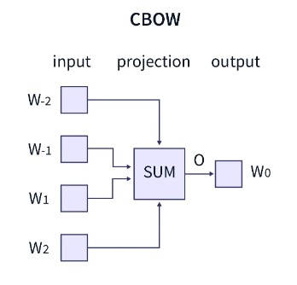 | 5 | 4 | CO3 | 1 | 3.6.2
12.a. | Explain GloVe word embeddings with example.  Solution:  GloVe is an unsupervised learning algorithm for word embeddings, meaning it represents words as dense vectors in a high-dimensional space. These vectors capture semantic relationships between words based on their co-occurrence in a large text corpus.  GloVe is based on word co-occurrence probabilities. Instead of predicting words like Word2Vec (which uses a moving window), GloVe constructs a co-occurrence matrix from a large corpus and factorizes it to learn meaningful word embeddings.  Why Use GloVe?  - Captures global meaning (unlike Word2Vec, which only focuses on local context).  - Efficient for large datasets like Wikipedia, Twitter, and Common Crawl.  - Useful for NLP applications like sentiment analysis, chatbots, and search engines.  Step-by-Step Example  Let's take a small example corpus:  "I like deep learning.  I like NLP.  I enjoy machine learning."  Step 1: Build a Co-occurrence Matrix  We first count how often words appear together in a window size (context size). Assume we use a window size of 2.  Each entry X(i, j) in the matrix represents how often word i appears near word j.  Step 2: Compute Probability Ratios  GloVe uses word co-occurrence probabilities:  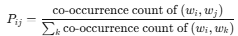  For example:  - P(learning | deep) is high since "deep" and "learning" appear together frequently.  - P(machine | deep) is low since they never appear together.  Step 3: Train the Model  GloVe finds word vectors by factorizing the matrix to satisfy the equation:  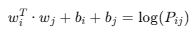  where:  - w_{i}, w_{j}​ are the word vectors.  - b_{i}, b_{j} are biases.  - P_{ij}​ is the co-occurrence probability.  By solving this equation using gradient descent, GloVe learns vector representations of words. | 5 | 3 | CO3 | 3 | 3.6.1
  Word | I | like | deep | learning | NLP | enjoy | machine
  I | 0 | 2 | 0 | 0 | 0 | 1 | 0
  like | 2 | 0 | 1 | 0 | 1 | 0 | 0
  deep | 0 | 1 | 0 | 1 | 0 | 0 | 0
  learning | 0 | 0 | 1 | 0 | 0 | 0 | 1
  NLP | 0 | 1 | 0 | 0 | 0 | 0 | 0
  enjoy | 1 | 0 | 0 | 0 | 0 | 0 | 1
  machine | 0 | 0 | 0 | 1 | 0 | 1 | 0
 | (OR)
12.b. | Given the sentence: "The cat sat on the mat."  How would the Skip-gram model of Word2Vec train using this sentence? What are the expected outputs?  Solution:  Target Word: Choose a word in the sentence as the target word. Let's say "sat" is the target.  Context Words: For a context window of 1 (one word to the left and one word to the right), the context words for "sat" would be ["The", "cat", "on", "the"].  Training Process: The model will learn to predict each of the context words from the target word "sat". The Skip-gram model would adjust its parameters so that the vector for "sat" is predictive of the vectors for the context words.  Multiple Target-Context Pairs: After training on multiple target-context pairs from the sentence, the model will learn vector representations for each word in the sentence. For example:  "The" → [vector for "The"]  "cat" → [vector for "cat"]  "sat" → [vector for "sat"]  "on" → [vector for "on"]  "mat" → [vector for "mat"]  Expected Outputs: After training, the Skip-gram model would generate word vectors where semantically similar words (e.g., "cat" and "mat") are close in the vector space. | 5 | 4 | CO3 | 3 | 3.6.2
13.a. | What is Self-Attention? Differentiate it with traditional attention mechanisms?  Solution:  Self-Attention is a type of attention mechanism where the input sequence attends to itself. Each token in the sequence is compared to every other token to compute a set of attention scores that indicate the relevance of each token to others.  Working Principle:  For each token in the sequence, self-attention calculates three vectors: Query  𝑄 Key K, and Value V.  The attention score for each token pair is computed as the dot product of the Query and Key vectors, followed by a softmax operation to normalize the scores.  attention_score_{ij}=softmax(Q_{i}⋅K_{j}^{T})  The final output is a weighted sum of the values (V), based on the attention scores.  Difference from Traditional Attention:  Traditional attention (e.g., in sequence-to-sequence models) uses information from an encoder (or previous layers) and decodes based on that.  In self-attention, all tokens in the input sequence are allowed to attend to each other, enabling the model to capture dependencies across all tokens simultaneously.  Applications:  BERT, GPT, and Transformer-based models.  Text classification, translation, and summarization. | 5 | 4 | CO4 | 1 | 3.6.4
 | (OR)
13.b. | Identify the limitations in RNN. In NLP sequence modelling how that problems can be resolved. Explain with example.  Solution:  Recurrent Neural Networks work just fine when we are dealing with short-term dependencies.    RNNs turn out to be quite effective.This is because this problem has nothing to do with the context of the statement. The RNN need not remember what was said before this, or what was its meaning, all they need to know is that in most cases the sky is blue.  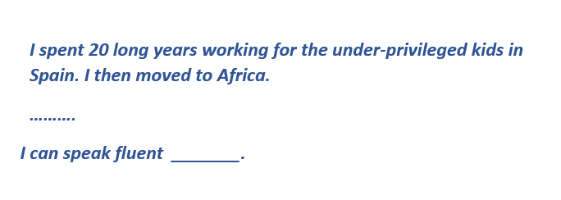  The reason behind this is the problem of Vanishing Gradient.  - Solution: LSTMs Long Short-Term Memory is a type of RNNs Recurrent Neural Network that can detain long-term dependencies in sequential data.  - LSTMs are able to process and analyze sequential data, such as time series, text, and speech.  - They use a memory cell and gates to control the flow of information, allowing them to selectively retain or discard information as needed and thus avoid the vanishing gradient problem that plagues traditional RNNs.  LSTMs are widely used in various applications such as natural language processing, speech recognition, and time series forecasting. | 5 | 4 | CO4 | 3 | 3.6.2
14.a. | Differentiate between BERT and RoBERTa model.  Solution:  RoBERTa and BERT are both transformer-based language models that use self-attention to process input sequences and generate contextualized representations of words in a sentence. The key differences between RoBERTa and BERT are:  - RoBERTa is a reimplementation of BERT with some modifications to the key hyperparameters and minor embedding tweaks.  - RoBERTa was trained on a much larger dataset and using a more effective training procedure.  - RoBERTa uses a byte-level BPE as a tokenizer (similar to GPT-2) and a different pretraining scheme. | 5 | 4 | CO4 | 1 | 3.6.2
 | (OR)
14.b. | Mention the Significance of Transformer Attention Mechanism.  Solution:  The attention mechanism in Transformers offers several advantages:  - Parallel Processing: Unlike RNNs, Transformers can process all words in a sequence simultaneously, significantly reducing training time.  - Long-Range Dependencies: The attention mechanism can capture relationships between distant words, addressing the limitations of traditional models that struggle with long-range dependencies.  - Scalability: Transformers can handle larger datasets and complex tasks due to their scalable architecture. | 5 | 3 | CO4 | 3 | 3.6.2
Part –C
Answer 2 questions (2 x 10=20 marks)
Q. No | Question | Marks | BL | CO | PO | PI Code
15.a. | Spiky is a US startup that develops an AI-based analytics tool to improve sales calls, training, and coaching sessions. It generates context and behavior-driven analytics and provides various unique communication and content-related metrics from vocal and non-verbal sources. In this startup company how NLP software solves the problem of identifying which “sense” (meaning) of a word is activated by the use of the word in a particular context or scenario. Mention its types in details with suitable example.  Solution:  Word Sense Disambiguation (WSD) is a subtask of Natural Language Processing that deals with the problem of identifying the correct sense of a word in context.  - Many words in natural language have multiple meanings  - WSD aims to disambiguate the correct sense of a word in a particular context.  - For example, the word “bank” can have different meanings in the sentences  - “I deposited money in the bank” and  - “The boat went down the river bank”.  Types: Word sense disambiguation -Word sense disambiguation is the automated process of identifying in which sense is a word used according to its context. As natural language consists of words with several meanings (polysemic), The objective here is to recognize the correct meaning based on its use.For example, ‘Raspberry Pi’ can refer to a fruit, a single-board computer, or even a company (UK-based foundation). Hence, it is critical to identify which meaning suits the word depending on its usage.  Lexical Disambiguation - The proposed approach solves lexical ambiguity in QA by considering two pieces of knowledge: context knowledge, and concepts knowledge. The combination of these knowledge is used to decide the most possible meaning of the word  Structural Disambiguation - Structural disambiguation is necessary whenever a sentence has more than one possible parse. There are many classes of structurally ambiguous sentence; | 10 | 5 | CO3 | 1 | 3.1.1
 | (OR)
15.b. | Mention the different approaches that are used for representing words and documents. For the below diagram express the types of different embedding techniques available in NLP.  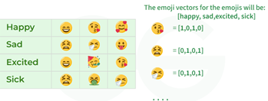  Solution:  - Word Embedding or Word Vector is a numeric vector input that represents a word in a lower-dimensional space.  - It allows words with similar meanings to have a similar representation.  - They can also approximate meaning.  - Word Embeddings are numeric representations of words in a lower-dimensional space, capturing semantic and syntactic information.  Goal of Word Embeddings  - To reduce dimensionality  - To use a word to predict the words around it  - Interword semantics must be captured  How are Word Embeddings used?  - They are used as input to machine learning models.  Take the words —-> Give their numeric representation —-> Use in training or inference  - To represent or visualize any underlying patterns of usage in the corpus that was used to train them.  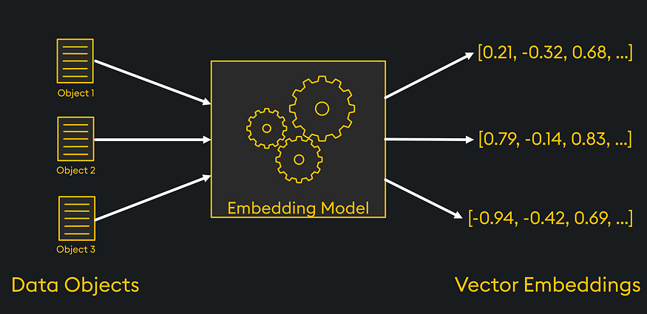  Approaches for Text Representation  - One-hot encoding  - Bag of Word (Bow)  - Term frequency-inverse document frequency (TF-IDF)  - Continuous Bag of words (BOW)  - Skip Gram model | 10 | 5 | CO3 | 5 | 3.1.2
16.a. | Explain in details the concepts of LSTM and its different layers.  Solution:  - LSTM is a special type of RNN designed to handle long-term dependencies.  - It introduces memory cells and gates (input, forget, and output gates) to control information flow.  - Used in machine translation, speech-to-text, and chatbot responses.  Architecture of LSTM  - Forget Gate: Decides which past information to discard.  - Input Gate: Controls what new information should be stored.  - Cell State: Stores long-term dependencies.  - Output Gate: Determines the final output at each step.  Diagram of LSTM  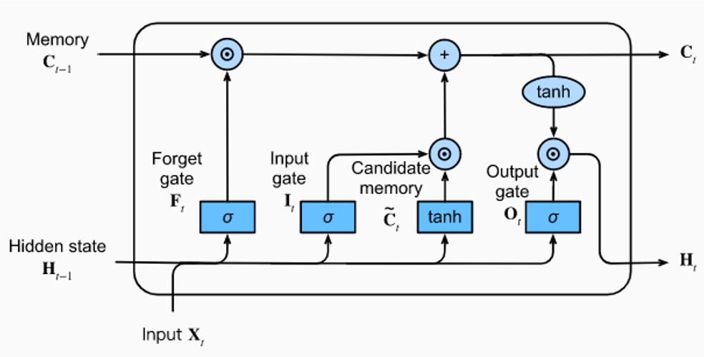  How LSTM Overcomes RNN Limitations  - RNNs are effective for short-term sequence learning but struggle with long-term dependencies.  - LSTMs improve upon RNNs by introducing gates that regulate memory retention.  - Both are widely used in natural language processing, speech recognition, and predictive analytics.  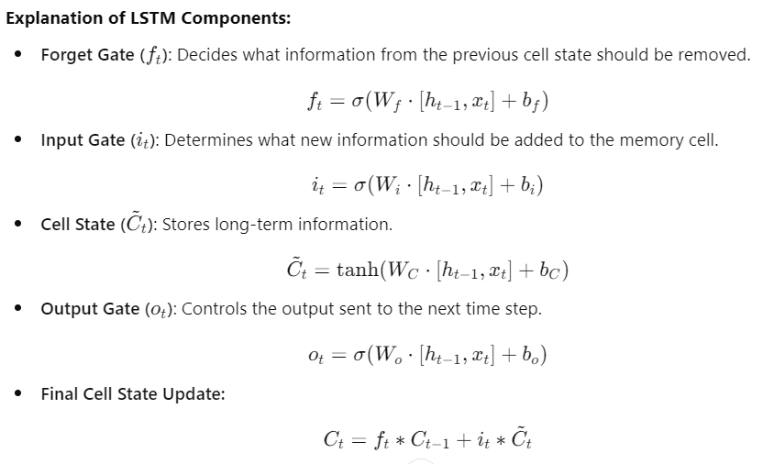  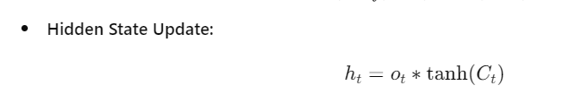 | 10 | 5 | CO4 | 1 | 3.2.2
  Feature | RNN | LSTM
  Memory Handling | Short-term memory only | Long-term memory retention
  Gradient Issues | Suffers from vanishing gradients | Uses gates to prevent vanishing gradients
  Sequence Length | Struggles with  long sequences | Efficient in processing long dependencies
  Use Cases | Simple sequential tasks | Complex NLP, translation, time-series
 | (OR)
16.b. | With proper example explain two different classification scenarios:  i) the classification of employees' working locations based on job reviews posted online (multiclass classification), and  ii) the classification of news articles as fake or not (binary classification).  Solution:  Definition: Assigning predefined labels to text data  Examples: Spam detection, sentiment analysis, topic categorization  Role in NLP: Helps in organizing, filtering, and understanding text data  Approaches:  Traditional Methods:  - Naïve Bayes  - Support Vector Machines (SVM)  - Decision Trees  Deep Learning-Based Methods:  - LSTMs & GRUs  - CNNs for text classification  - Transformer models (BERT, RoBERTa, etc.)  Steps in Text Classification:  - Data Preprocessing: Tokenization, Stopword Removal, Stemming, Lemmatization  - Feature Extraction: TF-IDF, Word Embeddings (Word2Vec, GloVe, FastText)  - Model Selection: Choose the appropriate model (ML, DL, Transformers)  - Training & Evaluation: Train on labeled data and validate performance  - Deployment & Optimization: Fine-tune the model for real-world applications  What are the types of classification?  There are a few ways to break down classification. Let’s look at those:  - Binary, multi-class, and multi-label - Denotes (1) the number of label options, and (2) how many classes the text can fall into.  - Hierarchical vs. flat - Refers to different ways to structure the classification algorithm.  - Supervised vs. unsupervised - Describes two approaches around label selection and annotation.  What is binary, multi-class, and multi-label text classification?  These terms highlight (1) the # of classes the model can choose from and (2) whether the text can be tagged with one or multiple classes (exclusive versus non-exclusive).  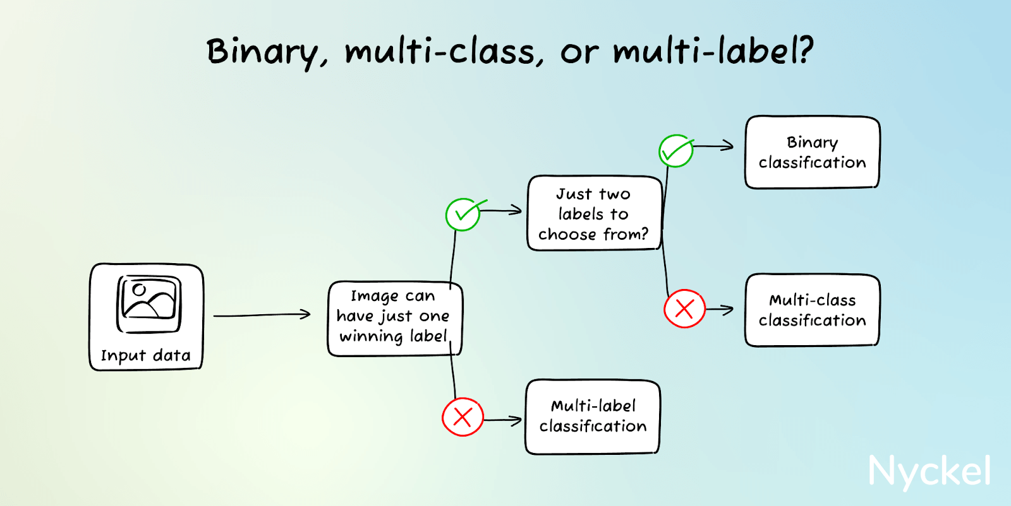 | 10 | 5 | CO4 | 3 | 3.2.2

